**Linked List Basics**

A linked-list is a sequence of data structures which are connected together via links.

Linked List is a sequence of links which contains items. Each link contains a connection to another link. Linked list the second most used data structure after array. Following are important terms to understand the concepts of Linked List.

* **Link** − Each Link of a linked list can store a data called an element.
* **Next** − Each Link of a linked list contain a link to next link called Next.
* **LinkedList** − A LinkedList contains the connection link to the first Link called First.

Linked List Representation

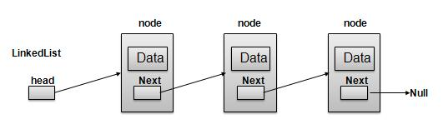

As per above shown illustration, following are the important points to be considered.

* LinkedList contains an link element called first.
* Each Link carries a data field(s) and a Link Field called next.
* Each Link is linked with its next link using its next link.
* Last Link carries a Link as null to mark the end of the list.

**Types of Linked List**

Following are the various flavours of linked list.

* **Simple Linked List** − Item Navigation is forward only.
* **Doubly Linked List** − Items can be navigated forward and backward way.
* **Circular Linked List** − Last item contains link of the first element as next and and first element has link to last element as prev.

**Basic Operations**

Following are the basic operations supported by a list.

* **Insertion** − add an element at the beginning of the list.
* **Deletion** − delete an element at the beginning of the list.
* **Display** − displaying complete list.
* **Search** − search an element using given key.
* **Delete** − delete an element using given key.

**Insertion Operation**

Insertion is a three step process −

* Create a new Link with provided data.
* Point New Link to old First Link.
* Point First Link to this New Link.

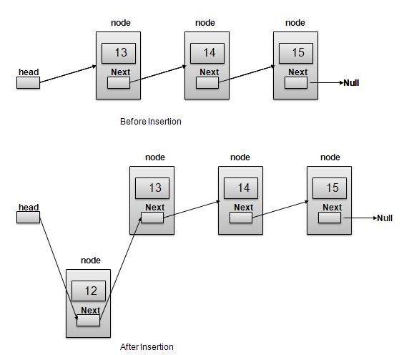

//insert link at the first location

void insertFirst(int key, int data){

//create a link

struct node *link = (struct node*) malloc(sizeof(struct node));

link->key = key;

link->data = data;

//point it to old first node

link->next = head;

//point first to new first node

head = link;

}

**Deletion Operation**

Deletion is a two step process −

* Get the Link pointed by First Link as Temp Link.
* Point First Link to Temp Link's Next Link.

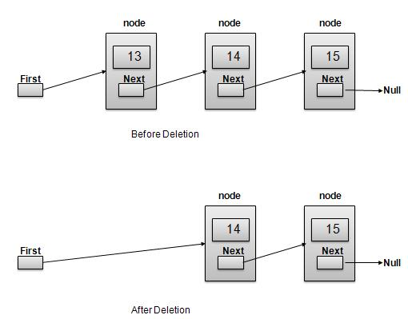

//delete first item

struct node* deleteFirst(){

//save reference to first link

struct node *tempLink = head;

//mark next to first link as first

head = head->next;

//return the deleted link

return tempLink;

}

**Navigation Operation**

Navigation is a recursive step process and is basis of many operations like search, delete etc. −

* Get the Link pointed by First Link as Current Link.
* Check if Current Link is not null and display it.
* Point Current Link to Next Link of Current Link and move to above step.

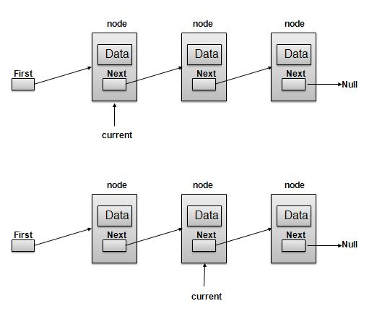

**Note −**

//display the list

void printList(){

struct node *ptr = head;

printf("\n[ ");

//start from the beginning

while(ptr != NULL){

printf("(%d,%d) ",ptr->key,ptr->data);

ptr = ptr->next;

}

printf(" ]");

}

**Advanced Operations**

Following are the advanced operations specified for a list.

* **Sort** − sorting a list based on a particular order.
* **Reverse** − reversing a linked list.

**Sort Operation**

We've used bubble sort to sort a list.

void sort(){

int i, j, k, tempKey, tempData ;

struct node *current;

struct node *next;

int size = length();

k = size ;

for ( i = 0 ; i < size - 1 ; i++, k-- ) {

current = head ;

next = head->next ;

for ( j = 1 ; j < k ; j++ ) {

if ( current->data > next->data ) {

tempData = current->data ;

current->data = next->data;

next->data = tempData ;

tempKey = current->key;

current->key = next->key;

next->key = tempKey;

}

current = current->next;

next = next->next;

}

}

}